Milton Primary School
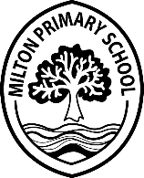
COVID POLICY – Child Absence/Child becoming Unwell in School
August 2020

- If a child feels unwell at school or has a persistent cough, staff will contact parents.
- Parents/Carers guidance - if child has COVID symptoms, NHS should be contacted and guidance followed https://www.nhs.uk/conditions/coronavirus-covid-19/
- No medical guidance can/should be given by school staff.
- If a test is being booked or has been carried out, the school should be informed. If a negative result is received, proof should be forwarded to the school office via office@milton-pri.s-lanark.sch.uk and NHS advice strictly followed regarding return to school.
- Please contact the school 24hours prior to pupils returning.

Siblings/Household
- If a non-symptomatic pupil who has someone in their household who is isolating, normal absence procedures should be followed. At the end of isolation or following a negative COVID test, children can return to school as normal.
- Please follow NHS advice strictly.

