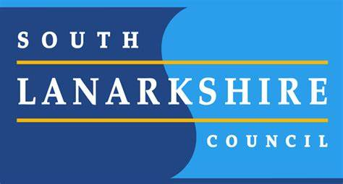
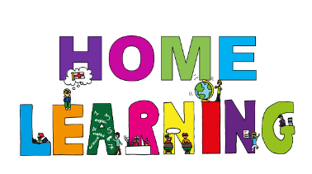

Milton Primary School
Remote Learning Policy January 2021
Definition of Continuity of Learning - Lockdown
The South Lanarkshire Council definition of Continuity of Learning in this context is the continuation of educational experience in the event of National Lockdown. It is a critical component of school emergency management, as it promotes the continuation of teaching and learning despite circumstances that interrupt normal school attendance.

Our aspiration is that continuity of learning during lockdown should be as close to the daily face to face experience as context allows.

GENERAL ADVICE & GUIDING PRINCIPLES

Our aim within Milton Primary during this period of remote learning is to continue to provide meaningful, quality learning and support for all – albeit at a distance during this second lockdown. Outlined below is the approach and guidance that we will work within over the coming weeks. We fully understand the complexities and pressures of remote learning and time constraints involved - please remember, as before, we are here to help and support and do not expect you as parents/carers to try and take on the role of the class teacher.

It is our expectation that all pupils will engage with remote learning on a regular basis. There is a video on each Google Classroom providing guidance on how to upload completed work. A weekly overview of learning will be provided, with daily opportunities for children to interact with their class teacher(s) via Google Classroom/Google Meet. We are still trying to balance the number of activities per class and this will adapt and change as we try our best to provide quality learning experiences for all leaners.

Digital devices can be borrowed from school, subject to availability, to support families during this time. Please contact the school (office@milton-pri.s-lanark.sch.uk) to discuss your needs. If you need any help with retrieval of passwords for Google Classroom or Education City please also contact our school office.

Whilst Google Classroom is our preferred platform for learning, we appreciate that families have different circumstances. Paper copies of the Google Classroom tasks can be collected at a pre-arranged time from the school office. Please be aware that these paper packs will exclude PowerPoint presentations and notes from pre-recorded teaching videos. Any group or class reading books that are required for remote learning with be delivered directly to families.

STRUCTURE OF THE DAY

An overview for the full week is posted each Monday morning at 8am to allow families to navigate and choose how to best approach the learning each day depending on individual schedules, work commitments and availability of devices. Any necessary resource sheets, slideshow presentations or videos will be posted under the classwork tab. There will be a daily check in question that all children will be expected to answer to allow staff to ascertain any individuals who have not accessed their remote learning. Please remember, as before, we are here to support in any way possible and as always staff will provide feedback on work handed in.

As already stated, we appreciate the difficulties that many families will have in terms of managing their own work and supporting home learning. Work can be competed in a flexible way which suits your own circumstances. Completed tasks should be handed in by 2.30 at the latest on Friday each week to ensure feedback is given but can be handed in at any point throughout the week. Work submitted after this time may not have all feedback given until the following week. Teachers will be available following their normal work pattern, unless they are on rota within the Milton hub. If this is the case, class teachers will inform pupils via their morning message on the stream and feedback on these days may be slightly delayed.

LIVE INTERACTIONS WITH STAFF
Teachers will be using the video-conferencing platform, Google Meet and the class stream to interact with their classes daily. These sessions will be an informal check in and an opportunity to engage with their teacher(s). This is not a direct teaching session at present and not a mandatory daily task.

LIVE TIMES – Same time each day
Mon/Wed/Fri – Video session
Tues/Thurs – Stream session
Primary 1 – Mrs Bryceland 9.30-10.00
Primary 2 - Mrs Black (Monday) 9.30-10.00, Miss McWee (Tues-Fri) 9.30-10.00
Primary 3 – Mrs Cherry 11.30-12.00
Primary 4 – Miss Weir 1.00-1.30
Primary 5 – Mrs Munogee 11.00-11.30
Primary 6 – Mrs Kerr 12.00-12.30 (see individual class message on Google Classroom)
Primary 7 - Miss Naismith (Tues and Fri) 10.00-10.30, Mrs Bunten (Mon, Wed, Thurs) 11.00-11.30
LIVE INTERACTION RULES (GOOGLE MEET)
- Cameras and microphones should be turned off, unless prompted by class teacher.
- These sessions are for pupil interactions only. Parents/Carers should not use these sessions to ask class teachers questions. All communication should be via our normal channels.
- Ensure that your child is watching the Meet from a safe place with no personal items visible.
- An additional member of staff will be in attendance to ensure safeguarding during all live sessions.
- No recordings of live sessions should be taken at any time, they will not be recorded by staff.

INSTRUCTIONS FOR JOINING A GOOGLE MEET
Although a very simple click on the Meet link via your child’s Google Classroom, additional detailed instructions with screen shots have been sent separately via email and can also be found on our school website - http://www.milton-pri.s-lanark.sch.uk

QUALITY ASSURANCE & MONITORING ENGAGEMENT
All teaching staff share weekly overviews with Mrs James before going live on Monday morning. Teaching staff provide updates throughout the day on progression of learning and/or any issues arising. Mrs James is part of each Google Classroom and all comments in the class stream are sent to the Head Teacher email account.
Staff inform Mrs James or Principal Teachers as to children who are not engaging in the daily question which serves as a daily register. At the end of each week, staff provide Mrs James with an engagement breakdown of work from each pupil. Any issues or lack of engagement in the daily register/set tasks will be followed up by staff to ascertain any additional support or technical help required.
Teaching staff and SMT are in pairs for live daily Google Meet sessions as a safeguarding precaution. All classes will have two staff members present during daily interaction slots.

COMMUNICATION
Staff are replying directly to questions answered by children via their Google Classroom and private comment section. Any parental enquiries should go via our normal channels. If you need retrieval of passwords or support with devices please in the first instance email our school office – office@milton-pri.s-lanark.sch.uk if you need to speak to a member of management please phone the school on 01555 894282.
Communication (this should give an overview of your communication and engagement strategy with staff, learners and parents.)
If you are in the school grounds or need to pick anything up from the school office, please remember a face covering should be worn.

