

**Education Resources**

**Milton Primary School**

**Handbook (November 2023)**

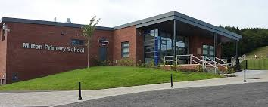

**Milton Primary School**

**Strathaven Road**

**Lesmahagow**

**ML11 0DN**

Phone – 01555 894282

Website - <http://www.milton-pri.s-lanark.sch.uk>

e-mail – [office@milton-pri.s-lanark.sch.uk](mailto:office@milton-pri.s-lanark.sch.uk)

Head Teacher – Mrs Lorna James

Stages of education provided for – Primary 1 – 7

Non-denominational

Present roll – 169

**Contents**

1. **Introduction**
2. **About our School**
3. **School Ethos**
4. **Attendance**
5. **Parental Involvement**
6. **The Curriculum**
7. **Assessment and Tracking Progress**
8. **Reporting**
9. **Enrolment/Transitions (Change of School/Placing requests)**
10. **Support for Pupils (Additional Support Needs)**

* **Getting it Right for every child**
* **Enquire**
* **Attachment Strategy**

1. **School Improvement**

* **Pupil Equity Funding**

1. **School Policies and Practical Information**

* **Nursery**
* **Free meals**
* **Uniform/dress code**
* **Clothing Grant**
* **Transport**

1. **General Data Protection Regulation as supplemented by the Data Protection Act 2018 (GDPR)**

If you need this information in another language or format, please contact us to discuss how we can best meet your needs.

Phone: 0303 123 1023  Email: [education@southlanrkshire.gov.uk](mailto:education@southlanrkshire.gov.uk)

**1) Introduction by the Head Teacher**

Dear Parents,

Welcome to the Milton Primary School handbook for session 2024/25. I hope it provides you with useful information about the school – our staff and facilities, our vision and values and our place in the local community.

Milton Primary School has a warm and caring ethos and we want your children to enjoy their time at Milton and look back on the happy times and learning opportunities we provide. Our staff are committed to working in partnership with parents to support the development and learning of all our pupils. We endeavour to provide a high standard of learning and teaching in a nurturing and stimulating environment to ensure all our learners are supported and encouraged in order to achieve their full potential.

There is an ‘open door’ policy in Milton which means that there is always a member of staff available to discuss any concerns or issues you may have. Your views and ideas are greatly appreciated and help us to continue to improve the quality of our service to you and your child.

I look forward to working in partnership with you to support your child’s learning and development.

Yours sincerely,

Mrs L. James

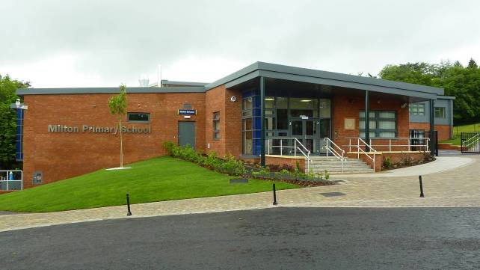

**Our Vision:**

To work actively in partnership to ensure every child achieves their full potential in an inclusive, supportive, safe, stimulating and motivating environment.

**Our Aims:**

* To ensure all pupils are nurtured, safe, active, healthy, achieving, included, respected and responsible.
* To promote rights and responsibility and through this, aim for every member of the school community to be treated with equality, fairness and respect.
* To provide a wide range of opportunities which give the children the capacity to become successful learners, confident individuals, responsible citizens and effective contributors.
* To improve the achievement and attainment by providing high quality education.

**Our Values:**

**H**ard-work

**E**nthusiasm

**A**chievement

**R**espect

**T**eam Work

At the heart of Milton is...

South Lanarkshire Council is the fifth largest authority in Scotland. It covers the following main areas; Clydesdale in the south which features extensive rural areas, Cambuslang, Rutherglen, Blantyre and Uddingston to the north as well as the towns of East Kilbride and Hamilton.

The Council’s Plan Connect sets out the Council’s Vision which is, “to improve the quality of life for all within South Lanarkshire”.

For Education Resources this means delivering services of the highest quality as well as striving to narrow the gap. It is about continually improving the services for everyone at the same time as giving priority to children, young people, families and communities in most need. The priorities for schools and services are set out in the Education Resources Plan which confirms the commitment to provide better learning opportunities and outcomes for children and young people.

Milton Primary is a non-denominational co-educational primary school which covers the full seven years of primary education. At present the school roll is 169.

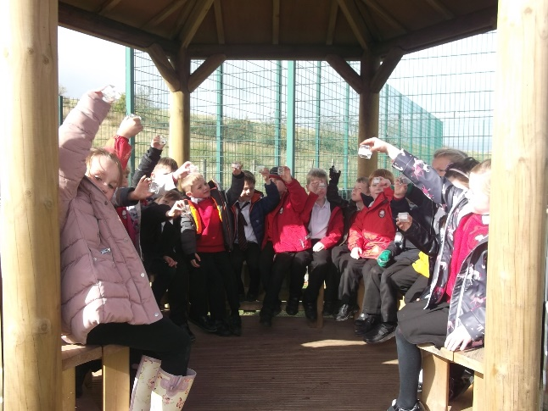

When we come to school, we make lots of friends.

Rosslyn

**2) About The School**

(Staffing as of 11/12/23)

Executive Director Ms Carole McKenzie

Head Teacher Mrs L James

Principal Teachers Mrs G Prentice

Mrs J Bunten

Class Teachers P1 Miss D Naismith

P2 Mrs C Bryceland

P3 Mrs A Kerr

P4 Miss D Weir

P5 Mrs C Black/Mrs Y Cherry

P6 Mrs L Munogee

P7 Mrs J Bunten/Mrs Y Cherry

Class Contact

Cover Teacher Mrs K Fox

Janitorial Mr R Mitchell

Support Staff Mrs G Smith

Mrs J Struthers

Mrs J Hefford

Miss L Gardiner

Miss S McGrath

Music Tutors Mr M Brawley

Mr S Pollock

**Parental Concerns**

Any parental concerns of any nature should be flagged up to the Head Teacher either by letter or by phone. If the Head Teacher is unavailable, then a message should be left with the School Support Staff asking for the Head Teacher to return the call as soon as possible. All concerns will be dealt with at the earliest possible opportunity.

**Parental Complaints**

The procedures outlined above would also apply to any parental complaints. Advice would also be sought, where necessary, from the Education Department in Hamilton.

**Pupil Absence or Sickness**

In the event of a child being off school for any reason, then it is important that parents contact the school to let us know. This can be done at any time out with school hours by leaving a message stating the child’s name, class and reason for absence on our school answering machine. During school hours a message can be given to our School Support Team – if possible before 9.30am.

If we do not receive a message from parents, then staff will use the numbers that we have on our system to contact parents. Although this can be a time consuming procedure it is important that we can account for all our children.

**New Pupils**

Throughout the year we can have many new families move into our catchment area. We are delighted to welcome them. Please contact the school to make an appointment to come along and meet us, tour our lovely school and discuss individual progress or needs.

**Visiting the School**

For reasons of security and safety we would ask that all visitors to the school enter the building via the front door and sign their names in the log kept there. Please also remember to sign out as, in the event of a fire, we would need to be able to account for all persons in the building.

**3) School Ethos**

Milton Primary promotes a culture of achievement for all our children. We aim to work in partnership with our children and their parents to support learning and teaching and motivate our children to engage with all learning opportunities within the school and our community. In line with Curriculum for Excellence our aim is to encourage our children to be successful learners, confident individuals, responsible citizens and effective contributors. Each child is encouraged to achieve their full potential and their contribution is valued. We aim to promote good citizenship and strong relationships as well as a respect for the rights of ourselves and others. We have been awarded our Rights Respecting School Level 1 status from UNICEF recognising our work in this area. We have also been given our Fairtrade School status and received a second Green Flag award for our work promoting eco awareness. Our weekly assemblies are used as a vehicle to promote the values and aims of our school. Academic achievements as well as success from out of school activities are celebrated in equal measure. We aim to forge links not only with the other schools within our Learning Community but also with the wider community that Milton serves. We promote positive behaviour through our Assertive Discipline procedures. Information and a snapshot of activities taking place in the school along with general information can be found on the school’s website : <http://www.milton-pri.s-lanark.sch.uk>

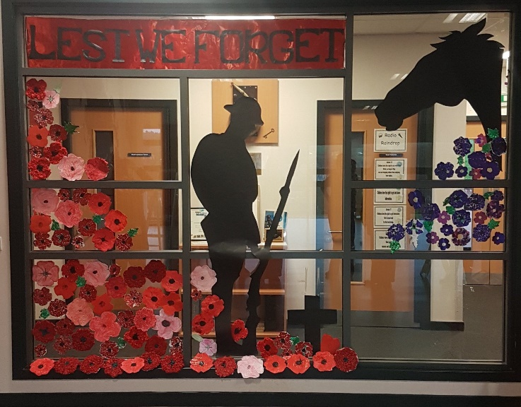

Milton Primary is part of the Lesmahagow Learning Community which encompasses Lesmahagow High School, Bent Primary, Blackwood Primary, Coalburn Primary and Woodpark Primary. A learning community is made up of schools and education establishments from the area including the secondary school, primary schools, early years establishments, early years partners and schools and bases which provide specialist additional learning services. It is about working together to plan better outcomes for children and young people. The Learning Community develops ways of working between establishments and with other agencies and organisations to ensure services are responsive, accessible and are delivered as effectively as possible.

Each learning community is managed by a Head of Education (Area). The Head of Education for our area is Ms Jacqueline Wallace.

Milton Primary recognises the importance of working in partnership with parents to support children’s learning. Information about a child’s learning on an individual basis is shared with parents through the Pupil Reports that are issued in October and May. Opportunities to meet with staff are also available in October and March. Arrangements to deal with any issues arising out with these pre-arranged times will be made on request.

As a result of continued monitoring of progress, some children may require some extra support to be put in place. This can take many forms: additional support plans being prepared (ASP), extra support from the Management Team as part of a short-life literacy or numeracy group, support from our visiting Additional Support teacher. Additional support is also provided from support staff which is reviewed regularly. Parents will be kept informed of their child’s inclusion in these groups and of their progress towards meeting the agreed targets.

**Extra-Curricular Activities**

We currently offer netball and football training. Teams of children representing the school take part in Learning Community football and netball leagues. We also run short-life after school activities at different stages: these have included badminton, athletics, dance, drama and choir. All children take part in our school sports day in the summer term and we regularly hold fitness events. We have an active Eco/Gardening Club helped by parent volunteers and a number of lunchtime clubs including active sports, Scripture Union and chess.

**Book Club**

To encourage a love of reading we run Scholastic Book clubs in school. Throughout the year your child will receive a leaflet describing books that can be ordered. If you wish to purchase a book, please follow the instructions on payment methods attached to order form. There is no obligation to take part.

We organise Book Fairs that normally take place during our Parent’s Night week. Commission raised by these events help the school to purchase new library books and we are always extremely grateful for the support we receive.

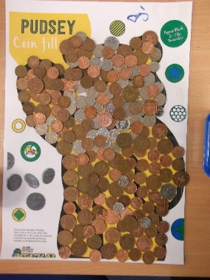

I like being on the charity committee and raising money for good causes.

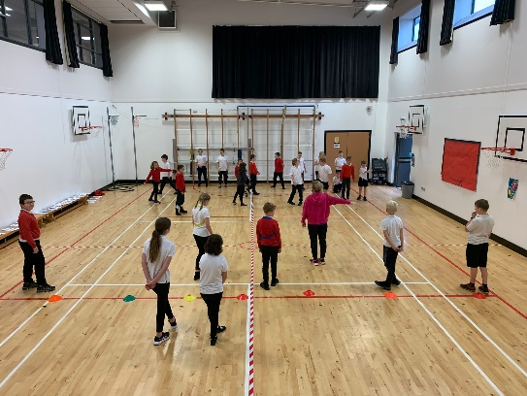

I like our active lunch clubs and I like being a sports leader.

**4) Attendance**

Every effort should be made to ensure that your child attends school during term time. Please contact the school as soon as possible if your child is unable to attend school. It is important for the school to work with parents/carers in encouraging children to attend school. All absences are required by law to be recorded. Absences will normally fall under two categories – authorised or unauthorised absence. In cases where your child is unable to attend school parents are asked to:

Contact the school office on the first day of absence and either leave a message on the answering machine (01555 894282) or send an email to our office – [office@milton-pri.s-lanark.sch.uk](mailto:office@milton-pri.s-lanark.sch.uk)

If you know they have a hospital/dental appointment, please let us know in advance.

Requests for your child to be absent from school to make an extended visit to relatives either in the UK or overseas must be made in writing to the head teacher, detailing the reason, destination and duration of absence and arrangements for their continuing education. On these occasions the pupil will be marked as an unauthorised absence.

Parents may request that their children be permitted to be absent in order to celebrate recognised religious events. Advance notice should be provided to the school when children will be absent. Appropriate requests will be granted, and the pupil noted as an authorised absentee in the register.

**Family Holidays During Term Time**

Every effort should be made to ensure that your child attends school during term time. Please contact the school as soon as possible if your child is unable to attend school.

Family holidays should be avoided during term time as this both disrupts the child’s education and reduces learning time. If holidays are taken during times when the school is open parents should inform the school in advance by letter.

If your child is taken on a family holiday during term time then in line with Scottish Government advice this will be classified as an unauthorised absence. However, in exceptional circumstances, schools may register a family holiday during term time as an authorised absence when for example, parents are unable to obtain leave during the school holiday period.

Clearly, absence with no explanation from parents will mean that the absence will be recorded as unauthorised.

In our approach to raising attainment and achievement, it is recognised that attendance at school is something that should be continuously encouraged. Parents/carers, children and the school all have a part to play in encouraging and stressing the importance of attendance at school.

The school holiday dates and in-service dates are available from the website [www.southlanarkshire.gov.uk](http://www.southlanarkshire.gov.uk) and can also be found at the end of this handbook for session 2024/25.

**Information on emergencies**

We make every effort to ensure the school remains open during term-time for pupils. However, on occasions circumstances may arise which can affect the school. Schools may be affected by, for example, severe weather, power failures or through any other circumstances that may impact on the school day. In such cases we shall do all we can to let you know as soon as possible. We shall keep in touch by the most appropriate method at the time normally through text message, and via our social media channels.

In cases of severe weather in the morning such as snow and a heavy frost and if there is a reason the school cannot open in the morning at the normal time, we will adopt the protocol for a delayed start until 10am.

If this is the case a message via social media and on the council’s website will be posted.

The Council’s website [www.southlanarkshire.gov.uk](http://www.southlanarkshire.gov.uk) and social media will be used to let you know if the school is closed or has a delayed start. Further information will be provided later in the day as to whether the school will be open as normal the next day. We will also keep families up to date via our website and Twitter account.

**Things we need you to do:**

* It is important for parents/carers to let the school know of any change to your mobile/home telephone number and change of address.
* If for any reason, you are unsure if the school is open visit the website [www.southlanarkshire.gov.uk](http://www.southlanarkshire.gov.uk) or email [education@southlanarkshire.gov.uk](mailto:education@southlanarkshire.gov.uk)

**Your commitments**

We ask that you:

* support and encourage your child’s learning – ask them what they have been doing.
* respect and adhere to the school’s policies and guidance.
* accept your responsibility to respect staff who work in the school and for the school to be proactive in taking forward its commitment to care for and educate your child.

**5) Parental Involvement**

South Lanarkshire Council recognises the importance of parents as partners in the education of their child and has published a strategy entitled, ‘Making a difference – working together to support children’s learning’. This is available from the Council’s website:

[www.southlanarkshire.gov.uk/downloads/file/13457/parents_as_partners_-_strategy_2019](http://www.southlanarkshire.gov.uk/downloads/file/13457/parents_as_partners_-_strategy_2019)

Parents, carers and family members are by far the most important influences on children’s lives. Children between the ages of 5 and 16 children spend only 15% of their time in school! Research shows that when parents are involved in their child’s learning, children do better at school and throughout life. Parental involvement can take different forms but we hope you share the same aims and agree that by working together we can be partners in supporting children’s learning.

As parents/carers we want you to be:

* Welcomed and given an opportunity to be involved in the life of the school;
* Fully informed about your child’s learning;
* Encouraged to make an active contribution to your child’s learning;
* Able to support learning at home;
* Encouraged to express your views and involved in forums and discussions on education related issues.

To find out more on how to be a parent helper, or a member of the Parent Council just contact the school or visit our website.

Some useful information contacts for parents to find out more on education are as follows:-

* Parentzone – [www.parentzonescotland.gov.uk](http://www.parentzonescotland.gov.uk)
* Engage Parent Forum – [www.engageforeducation.org](http://www.engageforeducation.org)
* National Parent Forum for Scotland – [www.educationscotland.gov.uk/parentzone](http://www.educationscotland.gov.uk/parentzone)
* South Lanarkshire Council – [www.southlanarkshire.gov.uk](http://www.southlanarkshire.gov.uk)

[Parentzone Scotland](https://education.gov.scot/parentzone) is a unique website for parents and carers in Scotland, from early years to beyond school.  The website provides up-to-date information about learning in Scotland, and practical advice and ideas to support children’s learning at home in literacy, numeracy, health and wellbeing and science. Information is also available on Parentzone Scotland regarding additional support needs, how parents can get involved in their child’s school and education.

Parentzone Scotland also has details about schools, including performance data for school leavers from S4-S6 and links to the national, local authority and school level data on the achievement of Curriculum for Excellence levels.

**6) The Curriculum**

Curriculum for Excellence is the name given to the new curriculum in Scotland for all children and young people aged 3-18. It is a forward- looking, coherent, more flexible and enriched curriculum that provides young people with opportunities to engage with the knowledge, skills and attributes they will need if they are to flourish in life, learning and work.

The curriculum places learners at the heart of education and at its centre are four fundamental capacities - successful learners, confident individuals, responsible citizens, and effective contributors. It includes all of the experiences that are planned for children and young people to support the development of their skills, wherever they are being educated, for example in the family and community, pre-school centre, nursery, and school.

In taking this forward our school will work closely with South Lanarkshire Education Resources and other services to enable Curriculum for Excellence to be fully embedded, ensuring the best possible education for all children and young people.

We wish you to feel confident that your child is encouraged and supported to develop their literacy, numeracy and other skills whilst they attend our school. The curricular areas are as follows:

* Expressive Arts
* Languages and literacy
* Health and wellbeing
* Mathematics and numeracy
* Religious and moral education
* Science
* Social studies
* Technologies

If you want to know more about Curriculum for Excellence, please visit [Scotland's Curriculum for Excellence (scotlandscurriculum.scot)](https://scotlandscurriculum.scot/)

Our learning and teaching activities are based on the outcomes and experiences in the guidelines that all schools have for Curriculum for Excellence.

**Level Stage**

Early The pre-school years and Primary 1 or later for some.

First To the end of Primary 4, but earlier or later for some.

Second To the end of Primary 7, but earlier or later for some.

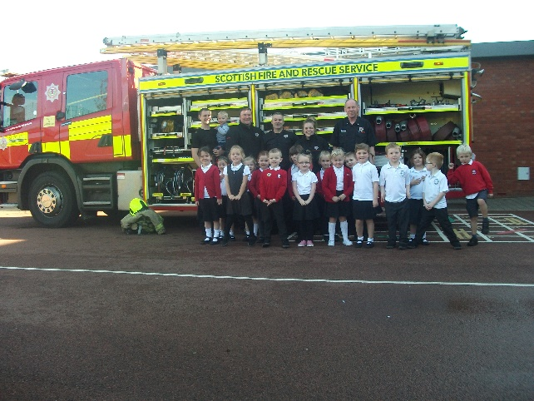 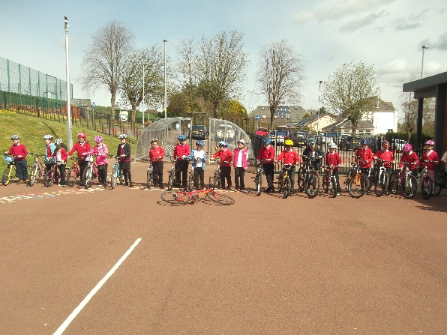

**Spiritual, Social, Moral and Cultural Values (Religious Observance)**

**Rights of Parents / Carers**

Scottish Government Ministers consider that religious observance complements religious education and is an important contribution to pupils’ development. It should also have a role in promoting the ethos of a school by bringing pupils together and creating a sense of community.

There is a statutory provision for parents to withdraw children from participation in religious observance. This right of parents’ wishes will be respected. Where a child is withdrawn from religious observance, schools will make suitable arrangements for the child to participate in a worthwhile alternative activity.

**Equalities**

Integral to this guidance is the principle of mutual respect. The diversity of belief and tradition provides an ideal context in which pupils can learn about, and so learn from, what is important in the lives of themselves and others. South Lanarkshire’s guidance recognises and welcomes diversity and promotes respectful understanding.

Parents may request that their children be permitted to be absent in order to celebrate recognised religious events. Advance notice should be provided to the school when children will be absent. Appropriate requests will be granted and the pupil noted as an authorised absentee in the register.

**7) Assessment**

Education Scotland’s website states that**, “**Assessment supports learning by focusing on the process of children and young people moving from where they are in their learning towards their desired goals. Assessment can also be used to identify and plan any support they will need to achieve these goals”. Assessment is an important part of learning and teaching. It helps to paint a picture of a pupil’s progress and achievements and to identify next steps in learning.

We want to share with you on how your child’s learning is progressing. In Milton Primary assessment takes place in a variety of forms. It happens informally on a daily basis when children’s work is discussed with their teacher and they receive feedback on their learning and progress. Children are encouraged to self-assess against given success criteria and are also involved in a variety of peer-assessment situations. End of unit assessments may well take place in maths or even the weekly spelling test.

More formal assessment procedures are also used. Information gained is used to identify children who need additional help to support their progress. It is also used to identify children whose excellent progress indicates that they need to be further challenged.

Tracking and monitoring of progress is an ongoing process in Milton Primary with progress regularly being discussed at planning meetings between staff and the Head Teacher. Children identified at these meetings as needing extra support or challenge will continue to be monitored while the class teacher implements intervention strategies. This process is outlined in the section in this handbook on Additional Support for Learning.

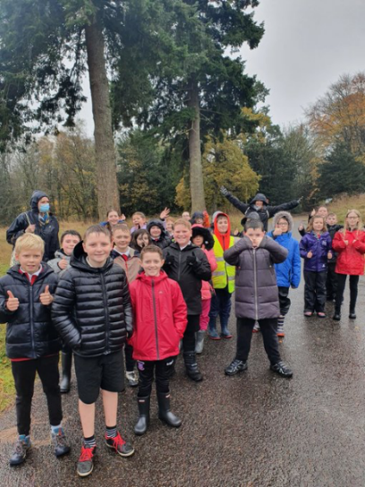 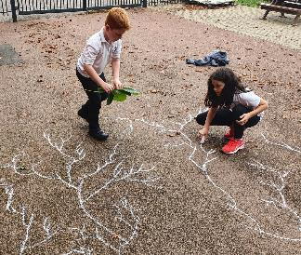 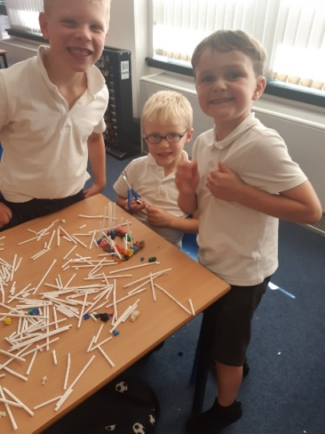

**8) Reporting**

The school`s arrangements and approaches for tracking and assessing pupils` progress and planning their future learning.

Our ‘learner reports’ will help you to get to know more about the curriculum which each child follows and will describe their strengths, achievements and areas for development so you know what encouragement and support you can give.

We welcome any comments or additional information from parents to help us provide the best possible education for your child.

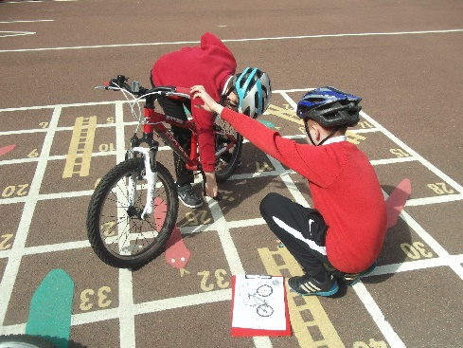 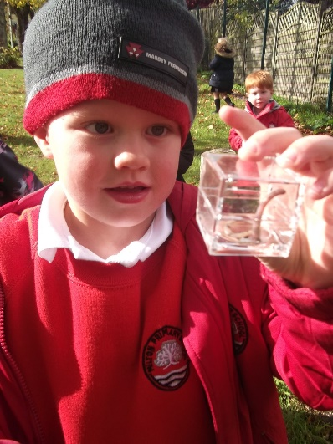 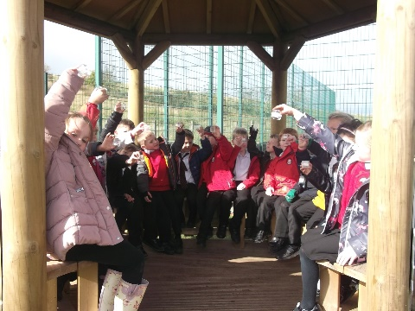

**9) Enrolment and Transitions**

**Enrolment – how to register your child for school**

To register your child for school you should complete our online registration form. This can be done using the South Lanarkshire website.

[www.southlanarkshire.gov.uk/info/200186/primary_school_information/392/enrolling_your_child_for_school](http://www.southlanarkshire.gov.uk/info/200186/primary_school_information/392/enrolling_your_child_for_school) If you have any difficulty in identifying your catchment school, please email [Edsuppserv.helpline@southlanarkshire.gov.uk](mailto:Edsuppserv.helpline@southlanarkshire.gov.uk)

The online registration form will ask you to provide each child’s full birth certificate and two pieces of recent official documentation both containing your permanent home address for example a utility bill, council tax statement, housing rent card, child benefit documentation. Proof of where the child lives may also be needed.

If your child is due to start school in August 2024, you can enrol online from Monday 8 January 2024. Your catchment school will contact you between Monday 15 to Friday 19 January 2024 to confirm your enrolment.

If your child attends the nursery of your catchment school, please do not assume that they will automatically be transferred. You must register them as normal at the school that is in the catchment area for your home address

If parents want their child to go to another school, they must enrol in the first instance with their catchment school and intimate that they wish to make a placing request. An online placing request form is available from the SLC website – [www.southlanarkshire.gov.uk](http://www.southlanarkshire.gov.uk) or by [contacting edsuppserv.helpline@southlanarkshire.gov.uk](mailto:contacting%20edsuppserv.helpline@southlanarkshire.gov.uk) or phone **0303 123 1023**.

**Change of School/Placing Request**

Normally children attend the school in their catchment area. However, there are times when parents may wish their children to go to other schools. If you wish your child to go to another school then you may make what is known as a ‘placing request’. If you live in South Lanarkshire and decide to submit a ‘placing request’, we are unable to reserve a place in your catchment school until the Council have made a decision on the ‘placing request’. Please note if your ‘placing request’ application is unsuccessful and all places at your catchment school are filled you will be offered a place at the next nearest appropriate South Lanarkshire School.

Please note that if an application for a ‘placing request’ is successful then school transport is not provided.

If you move out with your catchment primary school a ‘request to remain form’ must be completed. If you move out with your catchment primary, this may affect your right to transfer to the associated Secondary School. Please note the secondary school is determined by the pupil’s permanent home address and chosen denomination. If you require further information, please contact Education Support Services Support Services [edsuppserv.helpline@southlanarkshire.gov.uk](mailto:edsuppserv.helpline@southlanarkshire.gov.uk) or **0303 123 1023**.

**Transition from primary to secondary school**

Pupils normally transfer from primary to secondary school between the ages of 11½ or 12½, so that they will have the opportunity to complete at least 4 years of secondary education. Arrangements are made by the school to transfer children to the associated secondary school as determined by their home address. Parents of P7 children will be informed of the transfer arrangements made for their child to attend secondary school.

We will also provide you with information at this time on events designed to support P7 children before they move on to secondary school.

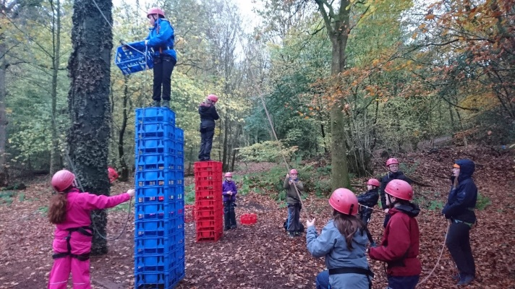

**10) Support for Pupils**

**Getting it right for every child.**

Getting it right for every child (GIRFEC) supports families by making sure children and young people can receive the right help, at the right time, from the right people. The aim is to help them to grow up feeling loved, safe and respected so that they can realise their full potential.

Most children and young people get all the help and support they need from their parent(s), wider family and community but sometimes, perhaps unexpectedly, they may need a bit of extra help. GIRFEC is a way for families to work in partnership with people who can support them, such as teachers

If you have any concerns about your child’s wellbeing, you can speak to the named person who will work with you to provide support and decide how to move forward Your school will let you know who this is. It is likely to be the Head Teacher in a primary school and a principal teacher (pupil support) in Secondary.

More information can be found on: [www.scotland.gov.uk/gettingitright](http://www.scotland.gov.uk/gettingitright)

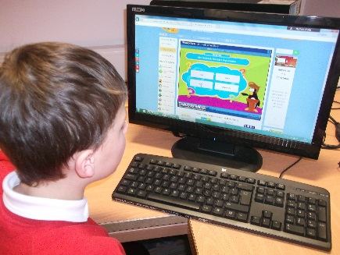

I think Milton is a great place to come and learn with your friends.

Sienna

**Support For All (Additional Support Needs)**

All children in Milton Primary are challenged and supported to achieve their maximum potential. For some children a programme of staged intervention is put in place. This consists in the first instance of extra class teacher input to target specific curricular areas.

If, in consultation with the Head Teacher, it is felt that more help is needed, a programme of support is planned. Advice is also sought from our Specialist Support for Learning Teacher. At this stage an Additional Support Plan (ASP) can be drawn up in consultation with parents and children. Children’s progress towards the targets set in their ASP will be noted in their ASP folder. The child’s opinion as well as feedback from their teacher will be shared with parents on a regular basis.

These programmes can also be helped by support from our School Support Assistants who play a valuable role in all areas of school life ranging from school administration to supporting individual children or groups within classes.

All our actions are guided by the council Additional Support for Learning guidelines. Any parental enquiries about Additional Support for Learning can be directed to the Head Teacher who will be happy to discuss any concerns. Parents may also be invited into school to help complete relevant paperwork and help us build up a more complete picture of a child’s needs.

South Lanarkshire Education Resources have published a series of leaflets which cover information for parents and carers about the Additional Support for Learning Acts. These are available through the school or on the South Lanarkshire Council website [www.southlanarkshire.gov.uk](http://www.southlanarkshire.gov.uk).

Enquire is funded by the Scottish Government to provide information on the framework for supporting children who require additional support for learning and to encourage positive partnerships between families, schools and local authorities to ensure children get the right support.

Enquire – the Scottish advice service for additional support for learning

Enquire offers independent, confidential advice and information on additional support for learning through:

Phone Helpline: 0345 123 2303

Address: Enquire Children in Scotland Rosebery House 9 Haymarket Terrace Edinburgh EH12 5EZ

Email Enquiry service: [info@enquire.org.uk](mailto:info@enquire.org.uk)

Advice and information is also available at [www.enquire.org.uk](http://www.enquire.org.uk)

Enquire provides a range of clear and easy-to-read guides and fact sheets including, ‘The Parents’ Guide to Additional Support for Learning’.

If you would like to order our leaflets, postcards or guides to share with parents and carers of pupils in your school, please contact us on [info@enquire.org.uk](mailto:info@enquire.org.uk)

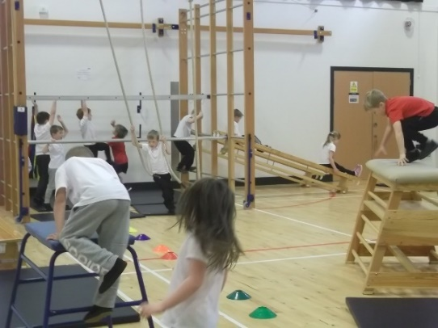

I love ICT and PE in Milton. They are my favourite subjects.

Alex

**Attachment Strategy for Education Resources**

**Attachment – what we do to support children and young people**

South Lanarkshire Council Education Resources is committed to improving outcomes for children and young people by creating emotionally supportive learning experiences in our nurseries and schools.

The Education Resources Attachment Strategy supports the action in the ‘Getting it Right for Every Child in South Lanarkshire’s Children Services Plan 2021-23’, following the launch of the Attachment Strategy in 2020, to provide staff training in Attachment and Trauma based practice.

***What does it set out to do?***

The aim of the strategy is to promote better experiences of attachment for South Lanarkshire’s children and young people and to ensure that all education practitioners understand the importance of attachment theory and its application and how positive relationships can make a difference to outcomes.

***How can I find out more?***

South Lanarkshire Council Education Resources have published a series of leaflets and posters for establishments and for parents/carers which aim to share information on attachment theory and on how this can inform the ways in which we support children and young people.

These are available in schools and on the SLC Staff Learning Centre Sway accessible by teachers and staff.

**11) School Improvement**

All South Lanarkshire schools are required to produce an annual Improvement Plan that outlines the areas of the curriculum or school improvement that will be the focus for the following year. Our school newsletters and website content will keep parents informed of our main achievements and allow parents to discuss current initiatives with their child. New initiatives being taken on board by the school will also be indicated in the annual summary of the school’s Improvement Plan progress sent out to parents in June of each year. The Improvement Plan priorities for the following year are discussed with staff in April/May of each year and planning for strategies to achieve these priorities begins to be developed. A draft of the plan is discussed and amended by staff before being presented to our Parent Council in June. It is then sent to our Quality Link Officer who comments and advises on the content. Our school newsletters and website will also keep parents informed of school activities and achievements and allow parents to discuss current initiatives with their child.

This session our Improvement Plan focused on Literacy (development of writing), Spelling Programme and Pedagogy and Development of Teacher Confidence in Assessment, Moderation. The Improvement Plan can be found on our school website and can be obtained from our school office.

Pupil plan priorities for 2023-2024 are:

* Develop links with two local care homes and Sheltered housing complex and share artwork and poetry with residents at various times throughout the year. The House and Vice Captains will continue to care for the Legacy garden and playground planters.

Our pupil plan is created and organised by the House Captains and Vice Captains.

Progress towards achieving our targets, outlined in the Improvement Plan, is discussed throughout the year with our Quality Link Officer.

Health and Wellbeing continues to be a focus for all staff in Milton Primary and the last audit carried out by our HWB working party confirmed that we are maintaining our status as a Gold Health Promoting School.

As part of our continuity of learning the school continues to focus on high standards of Literacy and Numeracy. We will also continue to develop our commitment towards raising awareness of the importance of physical, emotional and mental wellbeing using the new programme, Emotion Works across all stages.

**12) School Policies and Practical Information**

**School Meals**

Healthy eating is something that the school supports and a range of meals are available at lunchtime that meet Nutritional Requirements for Food and Drink in Schools (Scotland) Regulations 2020

All primary aged pupils are also offered a free breakfast within their school. The selection available includes cereal, toast, fruit and milk.

For their lunch each day pupils have the option to choose from two hot meal options, a snack option plus a vegan / vegetarian option. These are all served with vegetables or side salad. All meals also come with fresh chilled drinking water, salad, seasonal fruit and depending on the day - soup or a dessert.

Milk will be available for those pupils entitled to free school meals through the free school meal eligibility scheme at morning break or lunchtime.

Pupils in:

* Primary 1 - 5 receive a free school lunch.
* Primary 6 - 7 meal cost is £2.05

School lunches and milk can be paid for through your Parentpay account or Paypoint facilities in local shops.

**NB** School Meal prices are reviewed annually and may be subject to change.

**Adapted diets**

If your child within Nursery, Primary or Secondary requires a special diet for medical reasons please speak to the school/nursery office who will provide the request form for you to complete. In addition, if you have a cultural diet request for your child please speak to the school/nursery office who will provide you with a request form.

**Free School Meals**

Children of parents who receive the following benefits are entitled to a free lunchtime meal for their child:

Income Support, Universal Credit (where your take home pay is less than £660 per month), Job Seeker’s Allowance (income based), Employment and Support Allowance (income related), Working Tax Credit and Child Tax Credit (where your gross annual income does not exceed £7,920 as assessed by the HM Revenues and Customs), Child Tax Credit Only (where your gross annual income does not exceed £17,105 as assessed by the HM Revenues and Customs) or receive support under Part VI of the Immigration and Asylum Act 1999.

**If you are in receipt of Housing Benefit and/or Council Tax Reduction from us there is no need for you to apply online, we will use the information we hold to automatically award free school meals (P4 to S6) and/or school clothing grants (P1 to S6) to eligible families.**

We would encourage parents of children who are in receipt of any of the above benefits to take up this opportunity of having a meal provided for their child when they are at school.  Arrangements are in place so that children who receive free meals are not singled out and we encourage all children to remain in school at lunch time.

South Lanarkshire Council also offers a free Breakfast service. This service runs from 8.15am to 8.45am each school day. The janitor will be at the front door from 8.15 – 8.30 and pupils will enter via the front office door at this time. The janitor will then be on duty in the playground and anyone attending breakfast club from 8.30 should enter via the playground gate.

**Allergies**

A significant number of children and young people in our schools will have allergies and it is important that parents keep the school fully informed on these matters.

Allergies can present in a variety of ways and can occur at any point in a person’s life. Symptoms range from mild to severe. Children and young people known to have an allergy with moderate to severe symptoms will likely have a Health Care Plan drawn up by the NHS. This will detail symptoms and appropriate interventions.

It is vital that parents share this information with the school and continue to provide any updated information.

Where symptoms are mild and a Health Care Plan is not in place, parents should still continue to liaise regularly with the school on any new triggers, medications and actions required.

In all cases, our employees need to know your child’s symptoms, treatments and any actions required to help prevent exposure to the allergen and minimise the risk of allergic reactions.

Employees in schools will receive training on allergies and will liaise with parents and NHS on any additional specialist training required.

In supporting children and young people with allergies, school employees will operate in accordance with South Lanarkshire Council’s Safe Systems of Work / risk assessment and national guidance on the administration of medicines.

**School Uniform**

We ask all parents/carers to support the school by encouraging your child(ren) to adhere to the agreed dress code and the wearing of our school uniform. The wearing of a school uniform helps promote the identity of the school in the local community and helps create an ethos of sharing and pride in the school.

In addition, the wearing of a uniform helps towards increasing the protection of all pupils. The wearing of a uniform helps staff and the pupils to distinguish between who belongs to the school and those who may be visitors. This enables staff to approach and identify visitors more readily and helps in trying to offer a safer environment for pupils and teachers alike.

Equality of opportunity is an important aspect of the life of the school. Any proposals on the dress code and on what constitutes the school uniform will be the subject of discussion with the Parent Council and where appropriate consultation with parents, pupils and staff.

There are forms of dress which are unacceptable in all schools such as:

* the wearing of football colours
* clothing with slogans that may cause offence (anti-religious, symbolism or political slogans)

1. clothing which advertises alcohol, tobacco or drugs
2. clothing which can be deemed unsuitable in terms of health and safety grounds such as shell suits, combat style clothing, dangling earrings, loose fitting clothes particularly in practical classes
3. articles of clothing that could be deemed to inflict damage on other pupils or be used by others to do so
4. footwear that may damage flooring.

**The uniform worn by Milton Primary pupils is:**

Jumper, cardigan or sweatshirt – red

Trousers – black or grey

Blouse, shirt or polo shirt – white

PE Kit – white T-shirt and black shorts. It is important that children are suitably dressed for PE. Trainers worn outside should not be worn for PE as this could prove to be a danger. Please note that jewellery should be removed before PE sessions.

School ties and fleece/rain jackets are also available.

Uniforms can be ordered in the first instance using ParentPay via the school website (as this is the Council’s preferred method of payment) <http://www.milton-pri.s-lanark.sch.uk/>

alternatively contact the school office.

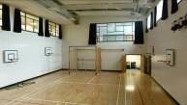There is pre-loved rail with both new and nearly new clothing. Please help yourself at any time to this or email the school office and items can be put in school bags.

School activities can involve the use of paint, glue or other messy materials so some sort of overall/old shirt for use in school is advisable. Please put children’s names on all clothing, shoes etc. A Lost Property area is situated in the school and parents are invited to retrieve jumpers etc. when visiting the school.

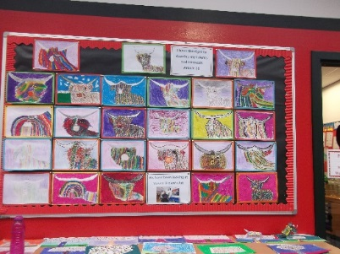

**Support for Parent/Carers**

**Clothing Grant**

In certain circumstances the Council provides support to parents/carers for the purchase of school wear.

Applications can be made online at www.southlanarkshire.gov.uk. If you are required to submit evidence of your Tax Credit income it is important that a copy of this evidence is attached to your online application. Should you require further information or you are unable to submit an application online then please contact the helpline number 0303 123 1011 (option 5).

**School Hours for Pupils**

Monday to Friday 9.00 am – 12.15 pm and 1.00 pm – 3.00 pm

Interval Morning only 10.30 am – 10.45 am

Lunch 12.15 pm – 1.00 pm

Details of school holidays/Inset days can be found in the appendices at the end of this handbook.

**Transport**

**School transport**

South Lanarkshire Council has a policy of providing school transport to primary pupils who live more than one mile by the recognised shortest walking route from their catchment school. This policy is more generous than the law requires. This means that the provision of transport could be reviewed at any time. Parents who consider they are eligible should complete a form online [www.southlanarkshire.gov.uk](http://www.southlanarkshire.gov.uk). or contact **0303 123 1023**. These forms should be completed and returned before the end of March for those pupils starting the school in August to enable the appropriate arrangements to be made. Applications may be submitted at any time throughout the year and will be considered by Education Resources.

A privilege transport scheme is operated for mainstream school contracts where a pupil is not entitled to free school transport. Privilege transport will only be granted providing there is spare capacity on an existing school contract and will be from and to designated pick up and drop off points. Privilege transport will not be provided where a service bus is used on the school run. Any spare capacity will be allocated using agreed priorities. More information on school transport is available at; [www.southlanarkshire.gov.uk/info/200188/secondary_school_information/545/school_transport](http://www.southlanarkshire.gov.uk/info/200188/secondary_school_information/545/school_transport) or phone **0303 123 1023.**

**Pick-up points**

Where school transport is provided it may be necessary for pupils to walk a certain distance to the vehicle pick-up point. Walking distance in total, including the distance from home to the pick-up point and from the drop-off point to the school in any one direction, will not exceed the authority’s distance limit for school transport.

It should be noted that it is the parent’s responsibility to ensure their child behaves in a safe and acceptable manner while travelling in and alighting from the vehicle. Misbehaviour can result in your child losing the right to school transport.

Parents are asked to note that South Lanarkshire Council does not provide transport for those pupils who attend school via a placing request.

Where there is a request to place a child under school age in a school within the local catchment area they may receive transport in line with the Council’s transport policy.

Transport to Milton is currently provided by:

* Go West
* Lanark Taxis
* KC Coaches
* JJC Travel
* Arrays Travel LTD

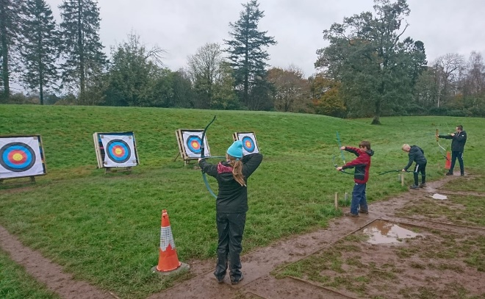 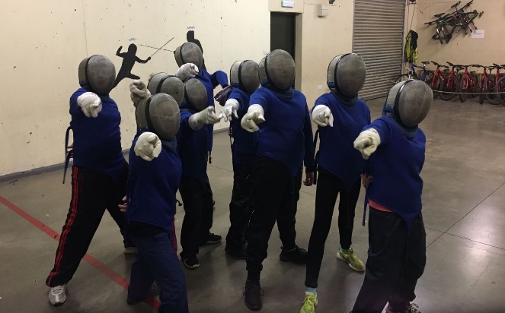

**Insurance for schools – pupil’s personal effects**

South Lanarkshire Council is concerned at the level of claims being received for loss or damage to pupils’ clothing or personal effects. Parents are asked to note the Council’s position in terms of insurance for pupils’ personal effects:

**(i) Theft/loss of personal effects**

The Council is not liable for the loss or theft of pupils’ clothing or personal effects and any items are therefore brought into the school at the pupil/parents’ own risk.

Parents can assist by ensuring that valuable items and unnecessarily expensive items of clothing are not brought to school.

Teachers and other staff have been advised not to accept custody of any such items.

The same principle applies to musical instruments and other equipment used for activities within the school, which belong to the pupil, but are brought into the school. Parents should be aware that if such equipment is left in school, it is done at the pupil/parents’ own risk.

In the case of valuable items such as musical instruments, parents should ensure that these items are covered by their own household insurance.

**(ii) Damage to clothing**

The Council is only liable for damage caused to pupils’ clothing where the damage has resulted from the negligence of the Council or one of its employees. Claims arising otherwise will not be accepted by the Council’s insurers.

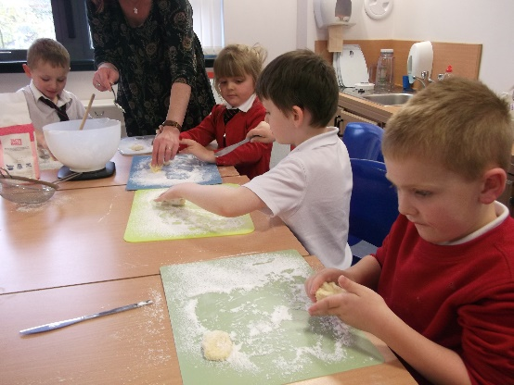

I like when we are learning outside. The teacher’s help me if I have any problems.

Ella

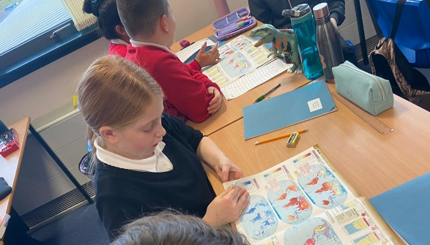 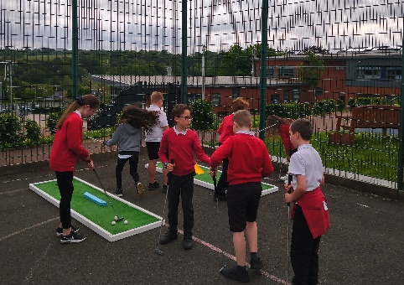

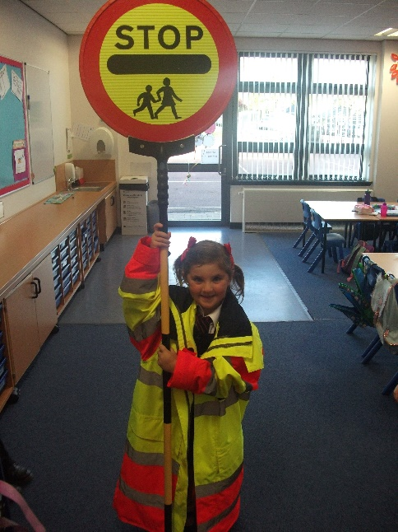

Milton is a great place for children to learn and have a good time.

Lennox

**Promoting Positive Behaviour**

It is the responsibility of staff within the school to ensure that parent council members, parents and pupils are involved in the creation of a positive school ethos that encourages good behaviour. Equally, the school whilst trying to promote positive behaviour must support young people should incidents or bullying occur. Parents have a significant role to play in working with the school so that teachers, parents and pupils know what is expected of them in trying to change the behaviour and attitudes that contribute to bullying behaviour.

Our approach is to create an environment where better behaviour will encourage better learning.

The school, along with the support of parents, can work together to create a learning environment which young people can enjoy and feel safe. Through our work on the Rights Respecting School initiative we promote respect for ourselves and others. Each class draws up their own class charter –an agreement on what should happen in their class. This then sits alongside our school charter.

Incidents of bullying should be reported to the school immediately so that each alleged incident can be looked at. Together we can work towards creating a safer school for children and staff.

In addition, a guideline (Promoting Positive Relationships and Behaviour) has been produced to support all teaching and support staff and inform them of their roles and responsibilities in respect of dealing with the small number of children and young people who display challenging behaviour. Early identification is crucial so that intervention can be provided to support children and young people to help them address their issues and concerns. Staff training is provided to help develop the skills needed to respond to and manage challenging behaviour. A wide range of appropriate staff development opportunities has been developed for this purpose.

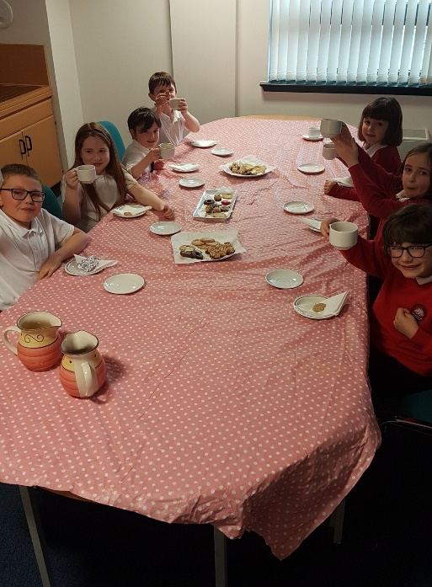

Milton Primary encourages children’s learning and has really fun activities!

Paige

**Child Protection**

All staff in educational establishments in South Lanarkshire Council are required to receive an annual Child Protection update and are required to follow the advice and guidance contained within relevant Education Operating Procedures. All staff must also complete a Learn on Line Course “Child Protection in Education”.

South Lanarkshire’s children’s services partnership works together to support children, young people and their families so that children grow up in communities where they are safe, healthy, active, achieving, respected, responsible and included, and have the opportunity to achieve their full potential. They are committed to continuously improve our services to ensure children, young people and their families get the right support at the right time.

Sometimes children and young people need additional help to make sure that they are *“cared for and protected from abuse and harm in a safe environment in which their rights are respected” (*CPC South Lanarkshire Child Protection shared vision). The Child Protection Committee has the overarching responsibility to ensure that agencies individually and collectively work to protect children and young people as effectively as possible.

All staff have a responsibility to report any suspicions that a child has been abused or is at risk of harm, abuse, or neglect. Robust procedures and guidance are in place to support education staff to: -

* be alert to signs that a child may be experiencing risks to their wellbeing,
* report concerns to the head of establishment or the child protection coordinator without delay.
* be actively engaged in support and protection and development of wellbeing.

If you would like more information, or if you have a concern of a child protection nature, please contact the head of the educational establishment which your child attends.

The Child Protection Committee’s website has a range of useful information for parents/carers to help them keep their children safe. [www.childprotectionsouthlanarkshire.org.uk](http://www.childprotectionsouthlanarkshire.org.uk)

**Keep Safe online**

The Council has produced an information leaflet – ‘stay safe’ for parents/carers on how to help ensure their child is safe when using the internet and mobile devices.

Copies are available from the school or the web: [www.southlanarkshire.gov.uk](http://www.southlanarkshire.gov.uk)

**Mobile Phones**

In line with the policy of SLC the use of mobile phones within the school is not permitted. Phones, if sent are not the responsibility of the school. They must be switched off at all times and kept in school bags for emergency use outside school. Any parent who wishes to contact their child during the school day should do so through the school office.

**Information on emergencies**

We make every effort to ensure the school remains open during term-time for pupils. However, on occasions circumstances may arise which can affect the school. Schools may be affected by, for example, severe weather, power failures or through any other circumstances that may impact on the school day. In such cases we shall do all we can to let you know if this happens. We shall keep you in touch by telephone, text, where appropriate, letters, web news and through local radio stations particularly if there are prolonged periods of severe weather. The Council’s website [www.southlanarkshire.gov.uk](http://www.southlanarkshire.gov.uk) will be used to let you know if the school is closed and when it will re-open.

It is important for parents/carers to let the school know of any change to your mobile/home telephone number and change of address.

If for any reason, you are unsure if the school is open visit the website [www.southlanarkshire.gov.uk](http://www.southlanarkshire.gov.uk) or email [education@southlanarkshire.gov.uk](mailto:education@southlanarkshire.gov.uk)

**Your commitments**

We ask that you:

* support and encourage your child’s learning
* respect and adhere to the school’s policies and guidance
* let the school know if you change your mobile/telephone number and/or address
* enjoy and take part in school activities
* accept your responsibility to respect staff who work in the school and for the school to be proactive in taking forward its commitment to care for and educate your child.

**13) General Data Protection Regulation as supplemented by the Data Protection Act 2018 (GDPR)**

Information on pupils, parents and guardians is held by the school to enable the teaching, registration and assessment of pupils as well as associated administrative duties. The information is stored and used as per the requirements of the GDPR, with South Lanarkshire Council defined as the data controller. The Council have established a data protection policy that applies to all of its school.

Education Resources has also prepared a privacy notice (below) which sets out how we will deal with personal information as part of our statutory function as an education authority. For more information, please contact the school.

**Privacy Notice**

**Introduction**

In line with the General Data Protection Regulation (GDPR) we have produced this privacy notice to inform you how we deal with personal information as part of our statutory function as an education authority.

The Council has a legal obligation to deliver effective education services to children, young people and adult learners in South Lanarkshire. In order to do this, we need to collect personal information about children, young people and their families so that we can help them to learn and keep them safe.

**Using your personal information**

The Council is a “controller” of the personal information you provide when enrolling for a nursery or school, applying for an education service or participating in groups or activities provided by Education Resources.

**Information we collect from you about you and your child at enrolment**

When you enrol for a nursery or school, we ask for the following information:

* parent/carer contact details (name, address, phone, email);
* the child’s name, date of birth, gender and address;
* information about medical conditions, additional support needs, religion and ethnicity;
* any information you may wish to provide about family circumstances.

**Information we collect at other times**

We will also collect information at other times such as when you apply for a benefit, request a services or other support. We will provide an additional privacy notice at these times.

* If you apply for an education service or benefit, such as school transport, free school meals, clothing grant, placing request or EMA, we will also ask for personal information as set out above. We will also ask for information about your income for education benefits applications.
* If you make a request for additional support such as an educational psychologist or other support for learning we will ask for more detailed information to allow us to provide the most appropriate support for your family. This may include information about family circumstances or medical conditions.
* If there are concerns about your child’s wellbeing and/or your child has needs that may require additional support, we will wish to work with you to collect and consider information to enable us to help you get the right support at the right time in line with the Getting it right for every child approach.

We require this information to ensure that children and young people are educated appropriately, supported, and that we take account of their health and wellbeing. We will also ask you to update this information annually and to tell us when there are changes to your details.

**Information that we collect from other sources**

As an education authority and as part of our statutory function in accordance with our legal obligations, we receive information from other sources such as the SQA, the NHS or Social Work about you or your child, this includes:

* exam results and assessment information;
* information about health, wellbeing or child protection.

**Why do we need this information?**

We need this information so the Council can ensure it is delivering education services appropriately to all learners:

* for the education of children, young people and adult learners;
* for teaching, enrolment and assessment purposes and to monitor the educational progress of children, young people and adult learners;
* to keep children and young people safe and provide guidance services in school;
* to identify where additional support is needed to help children, young people and adult learners with their learning;
* to maintain records of attendance, absence and behaviour of children and young people (including exclusions);
* to support children and young people moving on each year from nursery to primary, primary to secondary and when they move or leave school;
* to help us develop and improve education services provided for young people, adult learners or families
* In accordance with our legitimate interests as an education authority we will also use your information to create statistical reports.

**We will share your information with:**

As an education authority and as part of our statutory function in accordance with our legal obligations we will share information with other bodies or parts of the Council, including:

* The Scottish Government and bodies such as Education Scotland, Scottish Qualifications Authority, Skills Development Scotland and other organisations that support children and young people’s learning;
* Other parts of the Council when required for services such as school meals, school transport, education benefits and with Social work in connection with any child protection concerns we become aware of;
* The NHS, to support health initiatives in accordance with the legal obligation on the Council in terms of section 39(3) of the National Health Service (Scotland Act 1978;
* South Lanarkshire Leisure and Culture Limited, where children and young people are participating in sports and leisure activities;
* Other schools/local authorities – if a child moves or transfers to another school the Council has an obligation to pass on information with regards to pupil records to the new school/local authority.

You have the right to access your personal information as well as the rights of rectification, erasure, restriction and the right to object. For information on these rights and how to exercise them or for information about how we manage your personal information, you can get a copy of our full privacy notice from our website: (<https://www.southlanarkshire.gov.uk/info/200235/meta/1730/general_privacy>).

Our full privacy notice will also provide information on how to make a complaint or to request a paper copy of the privacy notice from the Data Protection Officer.



**Education Resources**

**School holiday Dates Session 2024/2025**

| **Types of holiday listed by month** | **Holiday dates** |
| --- | --- |
| **August 2024** | |
|  |
| Teachers return on Monday 12 August 2024 |  |  |
| In-service days - all schools | Monday 12 and Tuesday 13 August 2024 |  |
| Pupils return to school | Wednesday 14 August 2024 |  |
|  |  |  |
| **September 2024** | |  |
|  |
| September weekend | Friday 27 and Monday 30 September 2024 |  |
| **October 2024** | |  |
|  |
| October break | Monday 14 to Friday 18 October 2024  Pupils return on Monday 21 October 2024 |  |
| **November 2024** | |  |
|  |
| In-service day - all schools | Monday 11 November 2024 |  |
| **December 2024 and January 2025** | |  |
|  |
| Christmas/New Year | Schools close at 2.30pm on Friday 20 December 2024  Schools re-open on Monday 6 January 2025 |  |
|  |  |  |
| **February 2025** | |  |
|  |
| February break | Monday 17 and Tuesday 18 February 2025 |  |
| In-service day - all schools | Wednesday 19 February 2025 |  |
|  |  |  |
| **March/April 2025** | |  |
|  |
| Spring break/Easter | Schools close at 2.30pm on Friday 4 April 2025*  Schools re-open on Tuesday 22 April 2025 |  |
|  |  |  |
| **May 2025** | |  |
|  |
| In-service day - all schools | Thursday 1 May 2025 |  |
| May day | Monday 5 May 2025 |  |
| Local holiday | Friday 23 and Monday 26 May 2025** |  |
|  |  |  |
| **June 2025** | |  |
|  |
| Summer break | Schools close at 1pm on Wednesday 25 June 2025 |  |

* Good Friday falls on Friday 18 April 2025

** Lanark schools will close on Thursday 12 and Friday 13 June 2025

Pupils attend school for 190 days and teachers attend for 195 days.

**Appendix A**

**This annex gives a list of useful information and the links to the content is now available from the Council’s website by accessing the following link**

[**http://www.southlanarkshire.gov.uk/info/200186/primary_school_information/1264/curriculum_for_excellence/3**](http://www.southlanarkshire.gov.uk/info/200186/primary_school_information/1264/curriculum_for_excellence/3)

**The list is not intended to be exhaustive and authors may wish to consider additional sources of school, local and national information, material and resources.**

**Contact Details**

Education Scotland’s Communication Toolkit for engaging with parents

The Scottish Government guide Principles of Inclusive Communications provides information on communications and a self-assessment tool for public authorities

Choosing a School: A Guide for Parents - information on choosing a school and the placing request system

A guide for parents about school attendance explains parental responsibilities with regard to children’s attendance at school

**Parental Involvement**

Guidance on the Scottish Schools (Parental Involvement) Act 2006 provides guidance on the act for education authorities, Parent Councils and others

Parentzone provide information and resource for parents and Parent Councils. National Parent Forum for Scotland; [www.npfs.org.uk](http://www.npfs.org.uk)

**School Ethos**

Supporting Learners - guidance on the identification, planning and provision of support

Journey to Excellence - provides guidance and advice about culture and ethos

Health and wellbeing guidance on healthy living for local authorities and schools

Building Curriculum for Excellence Through Positive Behaviour and Relationships outlines the Scottish Government’s priority actions around positive behaviour in schools and is also a source of support

Scottish Catholic Education Service’s resource ‘This is Our Faith’ which supports the teaching and learning of Catholic religious education

**Curriculum**

Information about how the curriculum is structured and curriculum planning

Information about the outcomes a learner can expect to experience and achieve across literacy, numeracy and health and wellbeing, as well as the 8 curricular areas

Advice, practice and resources to support the experiences and outcomes on literary, numeracy and health and wellbeing

Broad General Education in the Secondary School – A Guide for Parents and Carers

Information on the Senior Phase

Information on Skills for learning, life and work

Information around the Scottish Government’s ‘Opportunities for All’ programme

Information for organisations responsible for the planning, management and delivery of career information, advice and guidance services

The Skills Development Scotland website ‘My World of Work’ offers a number of tools to support career planning

**Assessment and Reporting**

Building the Curriculum 5: a framework for assessment provides guidance around the assessment framework

Information about Curriculum for Excellence levels and how progress is assessed

Curriculum for Excellence factfile - Assessment and qualifications

Information on recognising achievement, reporting and profiling

**Transitions**

Curriculum for Excellence factfile - 3-18 Transitions - provides information on the transitions children and young people will face throughout their education and beyond

Career Information, Advice and Guidance in Scotland - A Framework for Service Redesign and Improvement provides guidance on career information, advice and guidance strategy

Choices and changes provides information about choices made at various stages of learning

The Additional support for learning page provides links to relevant legislation and guidance, including the arrangements that should be in place to support pupils with additional support needs

Supporting Children's Learning Code of Practice includes specific requirements on education authorities and others under the new legislation in relation to transition

Enquire is the Scottish advice service for additional support for learning

Parenting Across Scotland offers support to children and families in Scotland

**Support for Pupils**

The Additional support for learning page provides links to relevant legislation and guidance, including the arrangements that should be in place to support pupils with additional support needs

Information about the universal entitlement to support that underpins Curriculum for Excellence

Supporting Children's Learning Code of Practice (Revised edition) - provides Statutory guidance relating to the Education (Additional Support for Learning) (Scotland) Act 2004 as amended

Getting It Right For Every Child and Young Person, is essential reading for anyone involved or working with children and young people, including practitioners working in adult services with parents and carers

**School Improvement**

Scottish Schools Online - provides a range of school information, including contact details, school roll, facilities, website, inspection reports

Education Scotland’s Inspection and review page provides information on the inspection process

The Scottish Survey of Literacy and Numeracy (SSLN) is an annual sample survey which will monitor national performance in literacy and numeracy

Scottish Credit and Qualifications Framework (SCQF)

Scottish Qualifications Authority provides information for teachers, parents, employers and young people on qualifications

Amazing Things - information about youth awards in Scotland

Information on how to access statistics relating to School Education

**School Policies and Practical Information**

**National policies, information and guidance can be accessed from the Scottish Government website on** [**www.gov.scot**](http://www.gov.scot) **with an update on school inspection outcomes being available via the Education Scotland website.**